# **WiFiMCU(EMW3165)-Cortex M4-Lua WIFI Development Board**

Oct 26, 2015

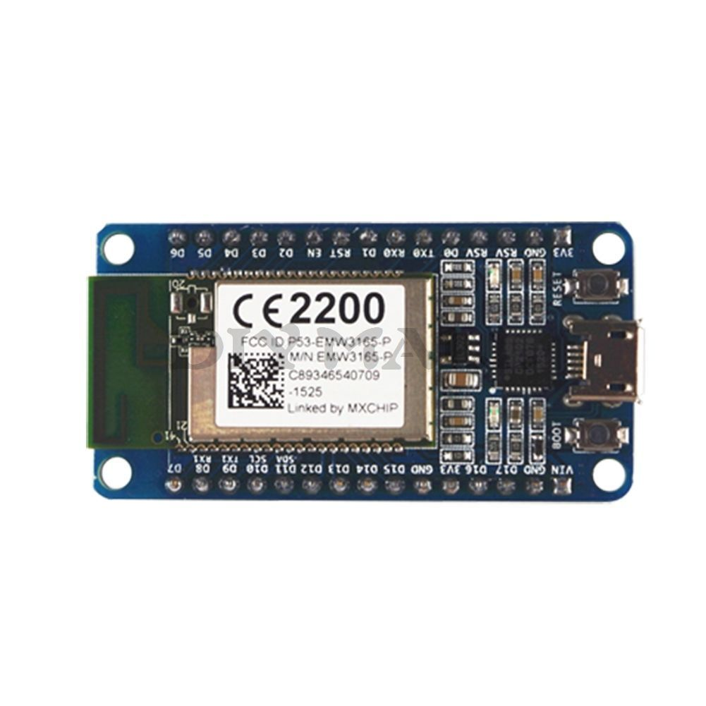

**Items Included:**

1 x WifiMCU - EMW3165 Cortex M4 based Development Board

**Item Description:**

EMW3165 is an embedded WiFi module which pairs an STM32F411CE ARM M4 microcontroller with a BCM43362 WiFi radio. Its a very good competing product for the ESP8266, with the exceptional advantage of being ARM based.

**MCU** – STMicro STM32F411CE ARM Cortex M4 micro-controller @ 100 MHz with 512KB flash, 128KB RAM, DSP, and FPU

**Storage** – 2MB SPI flash

**Wi-Fi connectivity:**

* 802.11b, 802.11g, 802.11n (single stream)
* WEP, WPA/WPA2 PSK/Enterprise
* 16.5dBm@11b; 14.5dBm@11g; 13.5dBm@11n
* Receiver Sensitivity – 87 dBm
* Station, Soft AP and Wi-Fi direct
* Support EasyLink
* On-board PCB antenna (EMW3165-P model) or IPEX connector for external antenna (EMW3165-E model)
* CE & FCC compliant

**Peripherals**:

* 22 GPIOs
* USART, I2C
* ADC, DAC
* Timer/PWM
* JTAG/SWD debug interface

**Reference Site** :<http://www.wifimcu.com/en.html>

**Code Repo** :<https://github.com/SmartArduino/WiFiMCU>

# Updated: Nov 9, 2018

Nothing much has changed, still no Arduino support, but here is some more info I did find.

<http://forum.espruino.com/conversations/276160/>

<http://www.wifimcu.com/#anli>

<https://github.com/SmartArduino/WiFiMCU>

<https://www.cnx-software.com/2015/10/30/10-wifimcu-board-is-a-nodemcu-clone-based-on-emw3165-module/>